Stone Barrett

Assignment 05

7/21/19

**Problem 1: Employees**

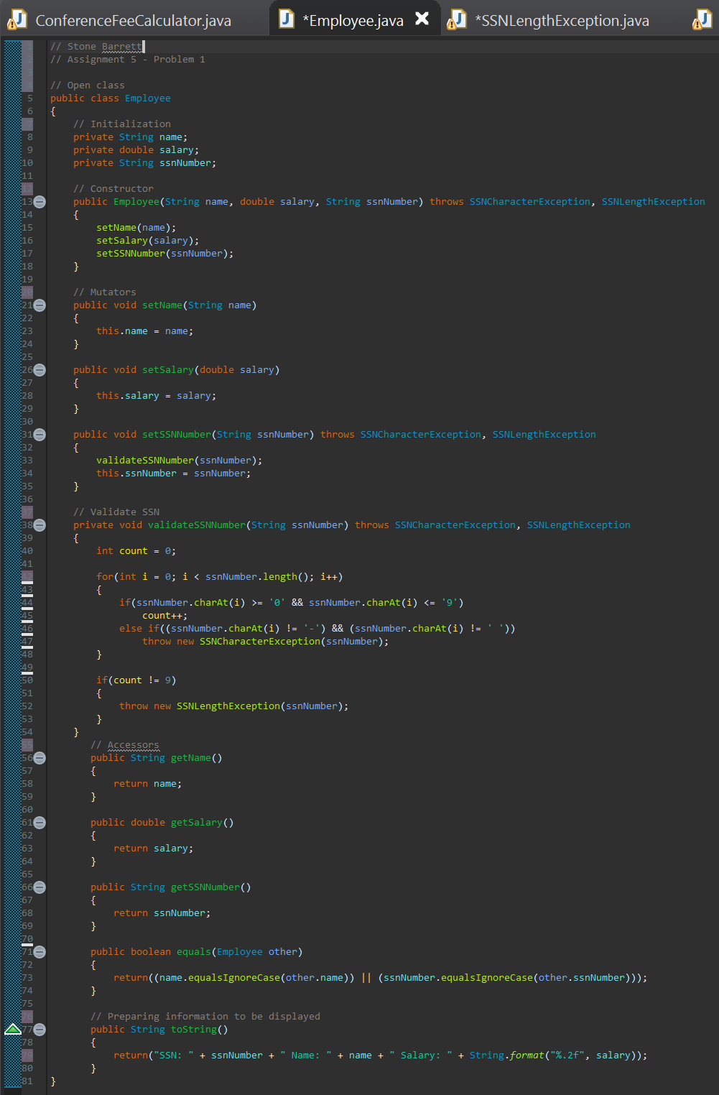For this program, two classes and two exception classes need to work well together. The first class, *Employee*, initializes variables for employee names, salaries, and social security numbers. It also creates getters and setters for those values, as well as methods to determine whether the SSN entered is appropriate (throwing exceptions *SSNCharacterException* and *SSNLengthException*) and converting information to a string to print. The second class, *EmployeeBuilder*, sets up a scanner and interfaces with a user to gain information about the employee(s). It checks whether the employee record entered already exists. It also calculates the average salary and returns whether an employee is above or below that value.

Screenshots:

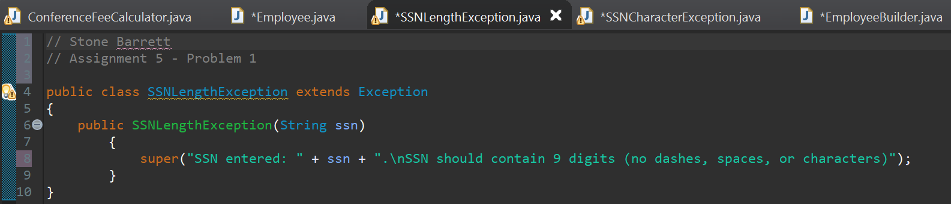

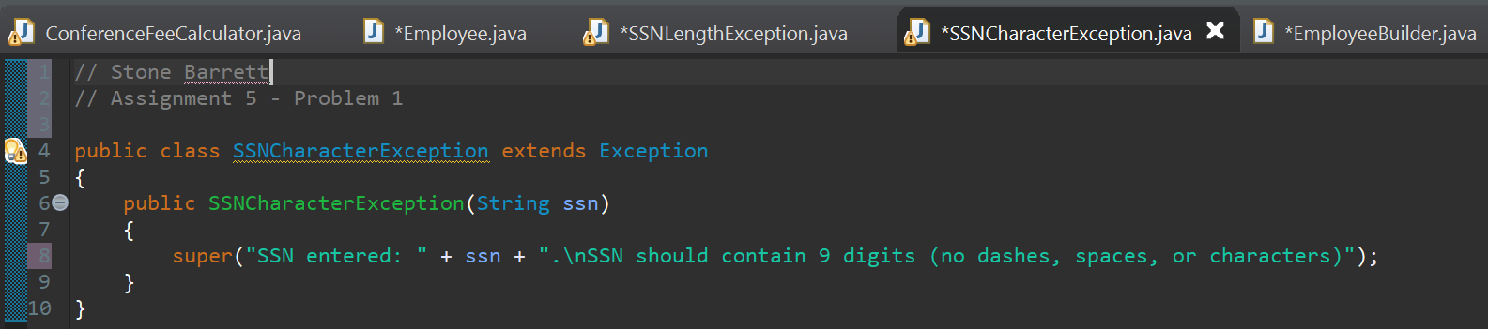

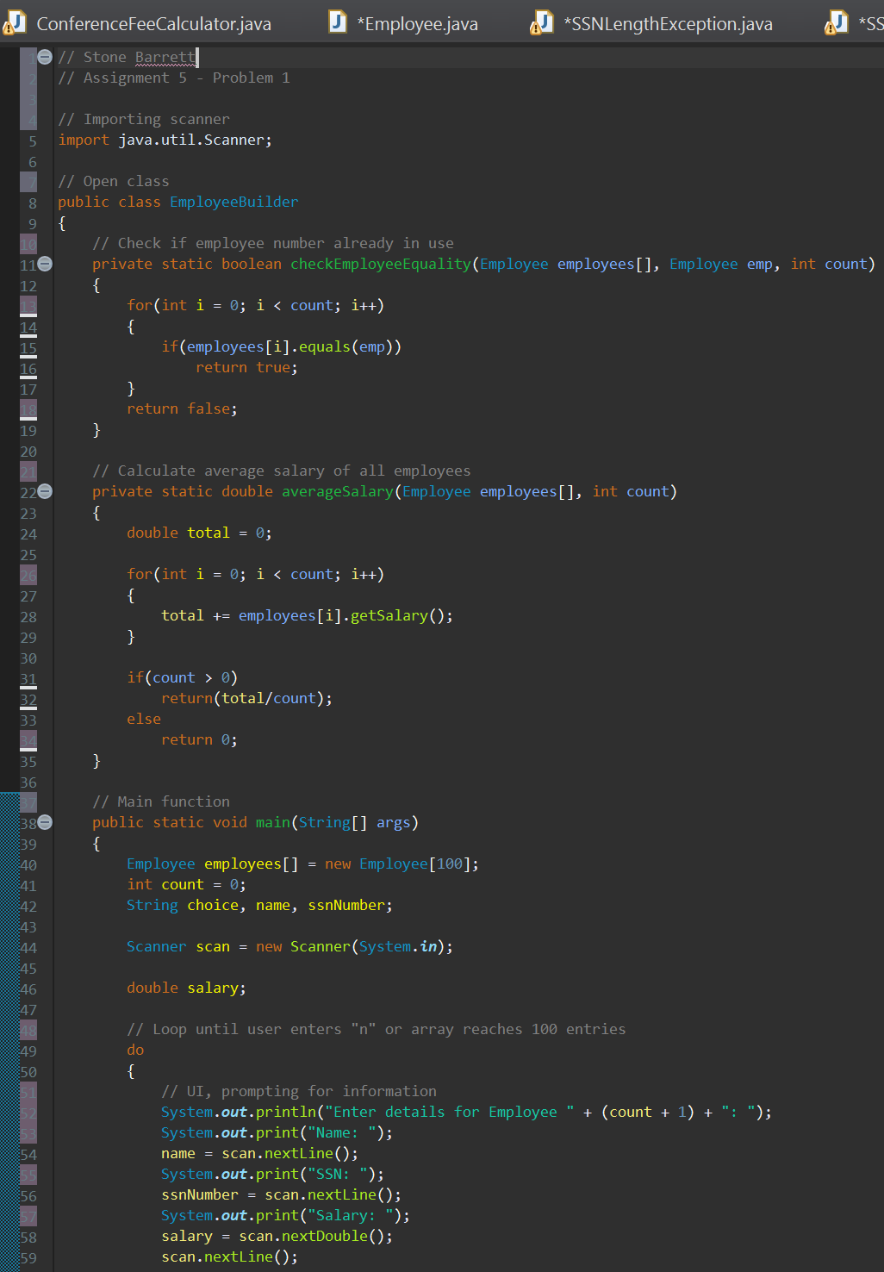

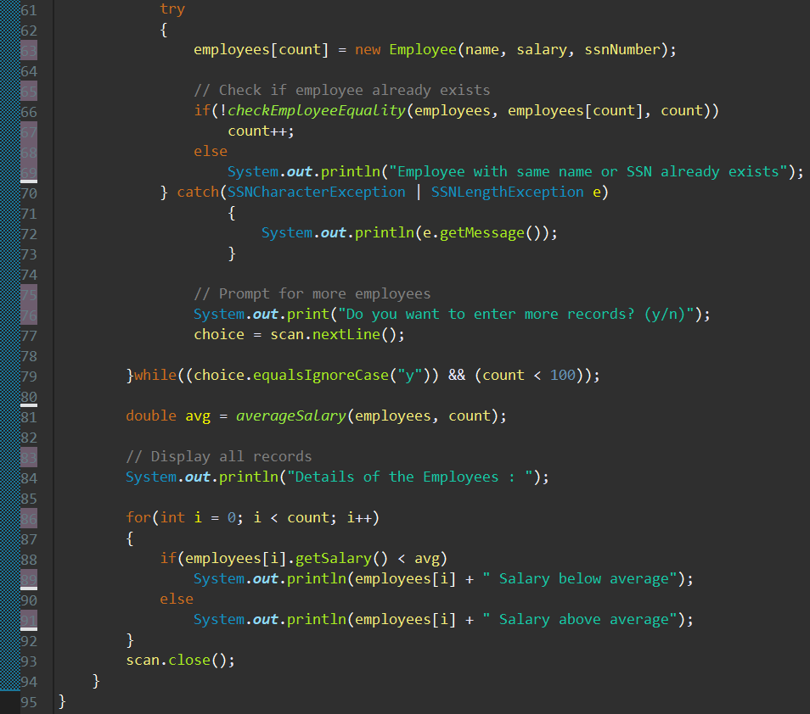

**Problem 2 (Bonus): Registration**

For this bonus problem, only one class is required but it is longer than the previous problem’s classes. This program imports all JavaFX libraries needed and is granted access to the JavaFX folder in the program files. It initializes the UI elements, including the buttons, check box, and drop-down menu. The stage and gridpane are set up and everything is positioned. The radio buttons are put into a toggle group so that only one can be selected at one time. The checkbox can be selected and deselected. The drop-down menu offers the different choices and one can be selected. The cost is updated whenever selections are made, then displayed in the bottom, right corner of the gridpane.

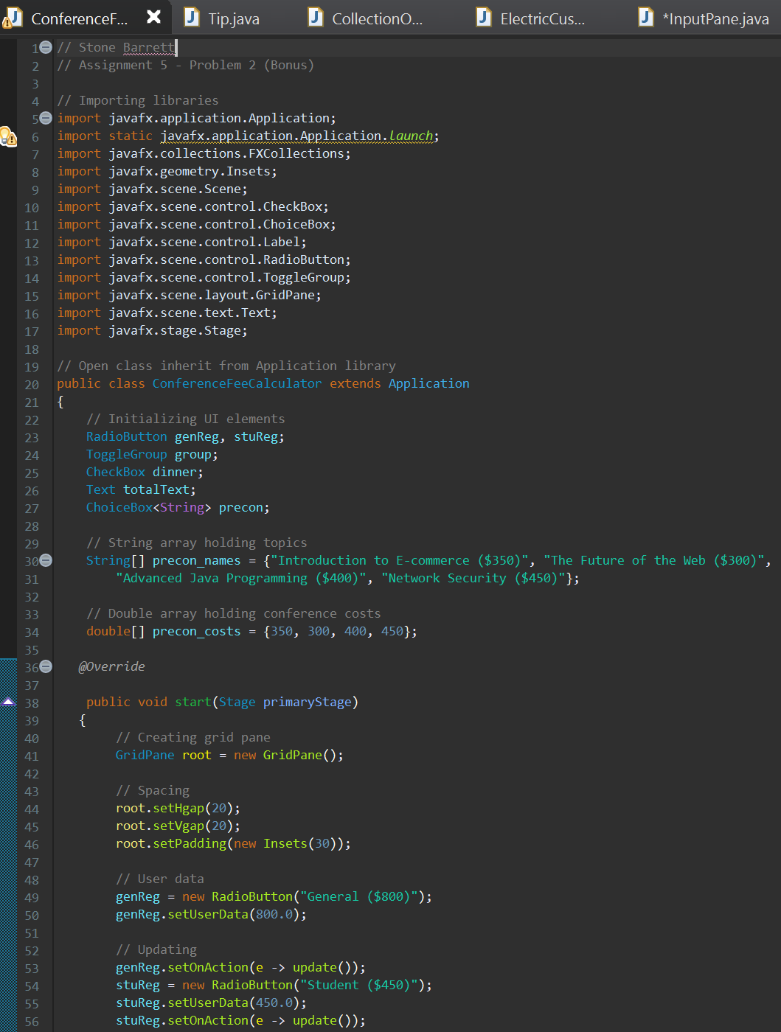Screenshots:

